Report on Irrelevant Mobile App Notifications

Step 1: Observation Points

Users receive frequent notifications that are not relevant to their interests or needs.
Many irrelevant notifications are promotional advertisements or repeated reminders.
Important alerts often get mixed with unnecessary notifications.
Users feel disturbed during work, study, or daily activities.
Many users ignore or mute notifications instead of engaging.

Step 2: User Identification

Mobile App Users:
Role: Users rely on mobile apps for communication, work, learning, entertainment, and daily tasks.
Expectations: Notifications should be relevant, timely, and useful.

Step 3: Survey Questions

1. How often do you receive irrelevant notifications?
2. Which type of notifications do you find irrelevant?
3. Do irrelevant notifications disturb your activities?
4. How do you react to irrelevant notifications?
5. How many apps have you muted?
6. Do you miss important notifications?
7. Satisfaction level with notifications?
8. Prefer permission before promotional notifications?
9. Would personalized notifications improve experience?
10. Have you uninstalled an app due to notifications?

Step 4: Survey Summary

Most users receive irrelevant notifications often or sometimes. Promotional ads and repeated reminders are common. Users feel disturbed and many mute or uninstall apps. Satisfaction level is moderate to low.

Step 5: Pain-Point Analysis

Functional: Notification overload
Emotional: Disturbance and irritation
Systemic: Poor notification filtering

Step 6: Root Cause Identification

Lack of personalization
Excessive promotional notifications
Poor prioritization of alerts

Step 7: Wicked Problem Understanding

Multiple stakeholders like users, developers, and marketers are involved. No single solution satisfies all.

Reflection

The study shows that relevance matters more than quantity. Better personalization and permission-based notifications can improve user experience.

Survey Response Screenshots
The following screenshots show the raw Google Form survey responses collected for this study:
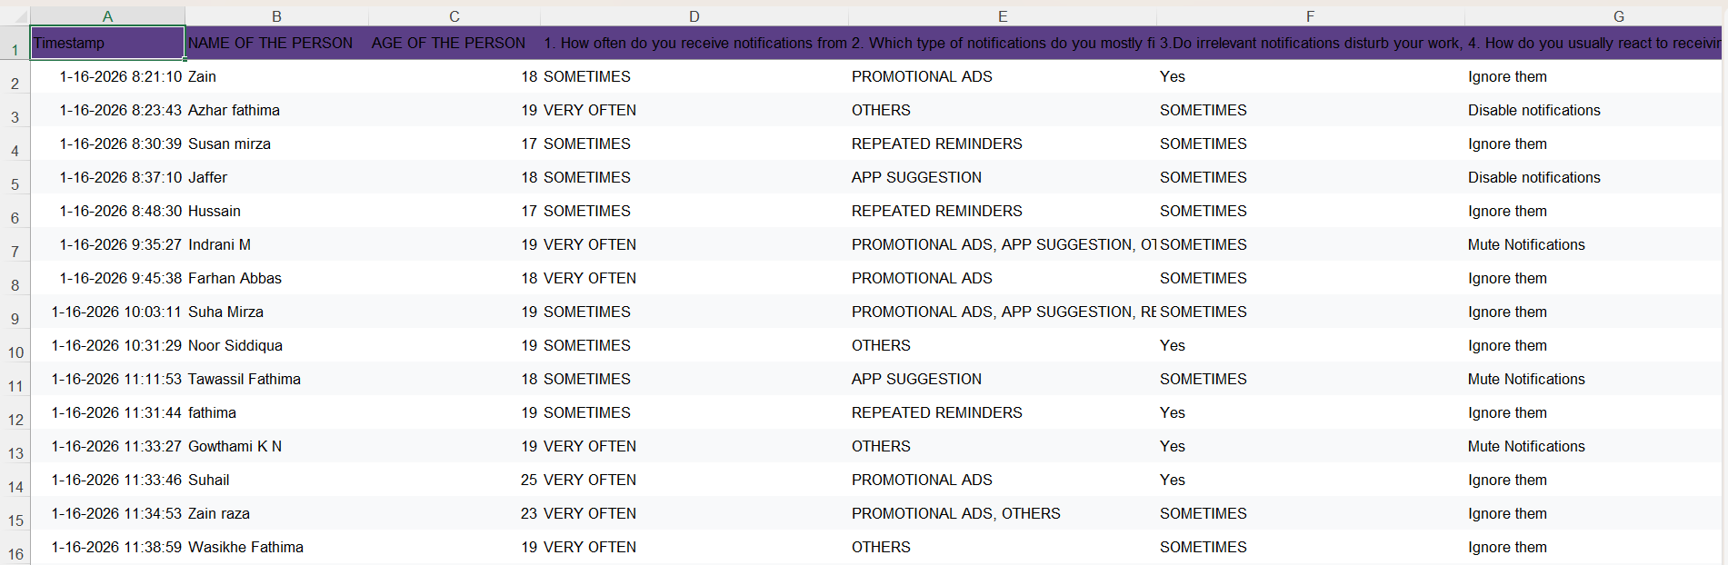
Figure 1: Google Form survey responses (Part 1)
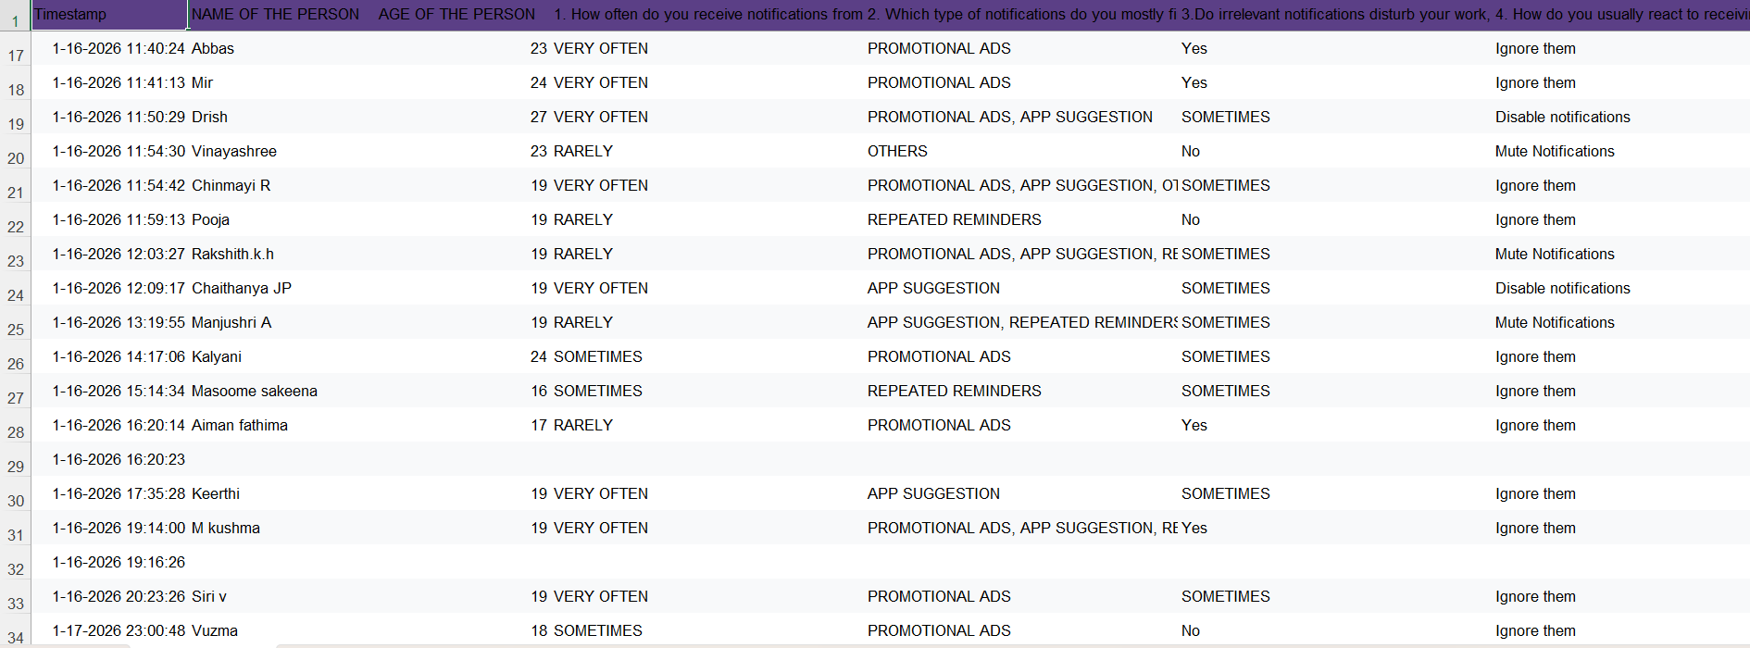
Figure 2: Google Form survey responses (Part 2)

Observation Points
- Users receive notifications frequently, many of which are not relevant to their interests.
- Promotional advertisements form the majority of unwanted notifications.
- Repeated reminders from apps create annoyance among users.
- Important notifications often get buried under less useful alerts.
- Users feel distracted during work, study, or daily activities.
- Continuous alerts reduce overall app engagement and trust.

Detailed Survey Analysis
- Most respondents reported receiving irrelevant notifications either 'Very Often' or 'Sometimes'.
- Younger users tend to mute or ignore notifications rather than disabling them completely.
- Promotional ads and app suggestions were marked as the most disturbing notification types.
- A noticeable number of users have uninstalled apps due to notification overload.
- Users who receive fewer notifications reported higher satisfaction levels.

Impact on Users
- Reduced concentration during important tasks.
- Increased irritation and mental fatigue.
- Missing critical alerts such as academic or work-related messages.
- Lower trust in app notification systems.

Suggestions and Recommendations
- Apps should request user permission before sending promotional notifications.
- Notification frequency should be adjustable by users.
- Important alerts should be prioritized over promotional content.
- Personalized notification systems should be implemented.
- Users should be given clear options to manage notification preferences.

Conclusion
The study clearly shows that irrelevant and excessive notifications negatively impact user experience. By improving personalization, reducing promotional alerts, and prioritizing important messages, apps can significantly enhance user satisfaction and engagement.

